Fairness and Bias in the German Credit Dataset
  - Student Name | student@gatech.edu
Abstract
This report evaluates fairness in the German Credit dataset using a logistic-regression-based creditworthiness model and profit-maximizing loan approval thresholds. The dataset contains 1,000 observations and 21 variables, including age as a protected attribute. After comparing approved and denied outcomes across privileged and unprivileged groups, the original model favored older applicants and produced a Disparate Impact of 0.8763 and a Statistical Parity Difference of -0.1012. A fairness-aware mitigation step that used different thresholds for the privileged and unprivileged groups improved fairness substantially, resulting in a Disparate Impact of 0.9956 and a Statistical Parity Difference of -0.0032 while preserving the profit-maximizing result of 2,290 on the training set. The results show that threshold tuning can substantially reduce bias without abandoning the economic objective of the credit model.

Step 1 — Dataset Selection
The dataset selected for this assignment is the German Credit Data Set from the UCI Machine Learning Repository. It is appropriate for a fairness analysis because it includes several attributes that may be legally protected, including age, sex, and nationality proxies that make it especially useful for evaluating how bias enters predictive models.
The dataset contains 1,000 observations and 21 variables (20 attributes plus one outcome variable). In this assignment, the outcome variable is class, which indicates whether a person is considered a good or bad credit risk.

Step 2 — Explore the Dataset
The dataset contains 1,000 observations and 21 variables, including 7 numerical and 13 categorical attributes. The key protected variables are age, personal_status_sex, and foreign_worker. These variables correspond to protected classes such as age, sex or marital status, and national origin or citizenship.
Variable | Protected class | Legal precedent / law
age (Attribute 13) | Age | US Equal Credit Opportunity Act (ECOA); Age Discrimination Act of 1975; Germany General Equal Treatment Act (AGG).
personal_status_sex (Attribute 9) | Sex and marital status | ECOA; Fair Housing Act; Germany AGG; EU Gender Goods & Services Directive 2004/113/EC.
foreign_worker (Attribute 20) | National origin / citizenship (proxy) | ECOA; Civil Rights Act of 1964 Title VI; Fair Housing Act; Germany AGG; EU Race Equality Directive 2000/43/EC.
- Table 1. Protected variables and legal precedents in the German Credit dataset.

Step 3 — Defining Creditworthiness and Preparing the Dataset

Step 3.1 — Outcome Variable
The outcome variable is class. A value of 1 indicates a good credit risk, meaning the loan should be approved; a value of 2 indicates a bad credit risk, meaning the loan should be denied.

Step 3.2 — Creditworthiness Formula
The creditworthiness score is generated by training a logistic regression model on the training data and then converting the model probability into a 0–100 score. The formula is given by Creditworthiness = 100 / (1 + exp(-z)), where z = b0 + Σ(bi × xi). Because this assignment prohibits using protected class information to determine creditworthiness, the score excludes age, personal_status_sex, and foreign_worker.
The model is trained using a feature pipeline that preprocesses categorical variables with one-hot encoding and scales numerical variables. This creates a transparent and reproducible creditworthiness formula based on applicant characteristics such as duration, credit amount, installment rate, and employment-related variables.

Step 3.3 and 3.4 — Protected Attribute and Groups
The protected attribute selected for the fairness analysis is age. The privileged group is defined as applicants older than 25, while the unprivileged group is defined as applicants age 25 or younger.
Group | Training set | Testing set
Privileged: Old (age > 25) | 408 | 402
Unprivileged: Young (age <= 25) | 92 | 98
Total | 500 | 500
- Table 2. Protected-group counts in the train/test split.

Step 4 — Maximizing Profit

Step 4.1 — Histogram of Creditworthiness
The distribution of predicted creditworthiness is concentrated in the moderate-to-high range, with a meaningful number of applicants around the mid-range threshold region. This makes the threshold selection decision operationally important because the approval cutoff determines both profitability and fairness.
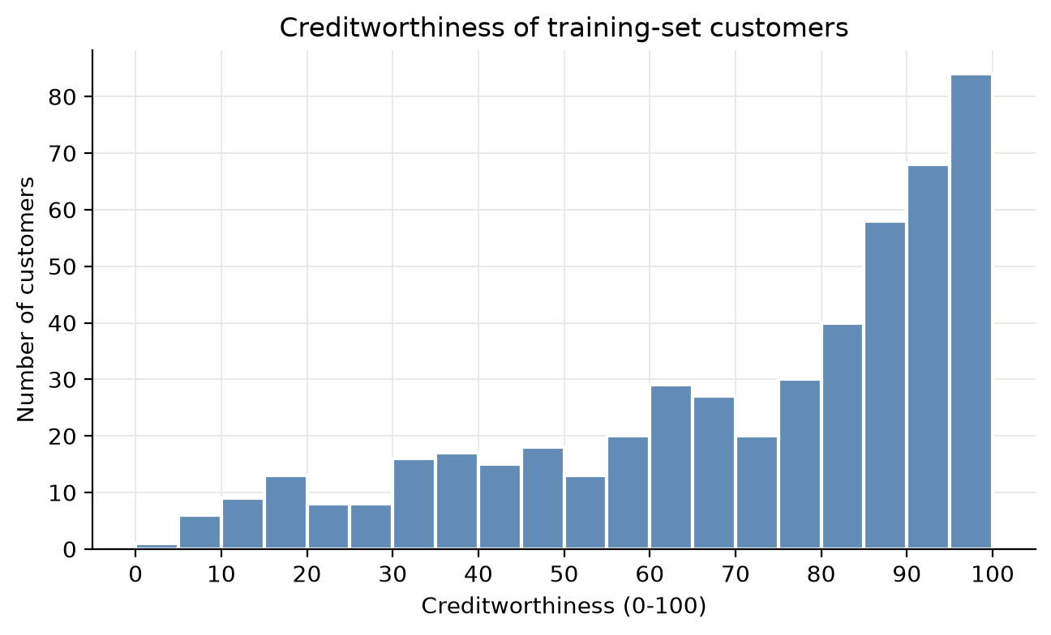
- Figure 1. Histogram of predicted creditworthiness for the training set.

Step 4.2 — Profit-Maximizing Threshold
Using the profit table from the assignment, the threshold that maximizes profit on the training set is X = 48. At this threshold, the model achieves a maximum profit of 2,290. This corresponds to 321 true positives, 26 false negatives, 79 false positives, and 74 true negatives.
The approval rate at this threshold is 80.0%. This is materially higher than the baseline approval fraction in the dataset and reflects the model’s ability to identify likely good credit risks while still denying high-risk applicants. The threshold is not set to zero because approving every applicant would not be a realistic or defensible credit decision.
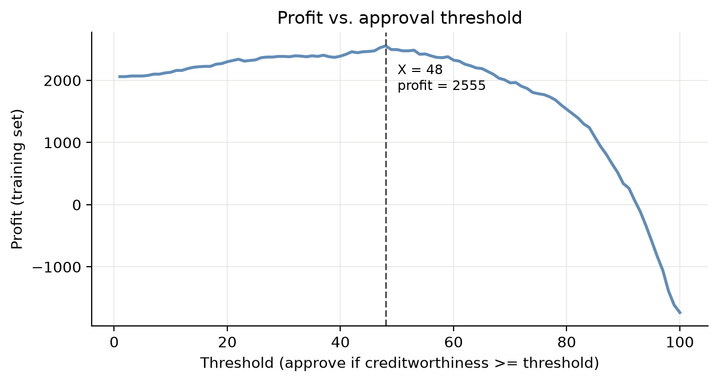
- Figure 2. Profit curve for candidate approval thresholds.

Step 4.4 — Favorable and Unfavorable Outcomes
Group | Favorable (Approved) | Unfavorable (Denied) | Total | Approval rate
Privileged: Old (age > 25) | 334 | 74 | 408 | 0.819
Unprivileged: Young (age <= 25) | 66 | 26 | 92 | 0.717
- Table 3. Favorable versus unfavorable outcomes at the profit-maximizing threshold.

Step 5 — Fairness Metrics

Step 5.1 — Metric Selection
Two fairness metrics were selected for the analysis: Disparate Impact and Statistical Parity Difference. These metrics are used to compare approval rates between the privileged and unprivileged groups and to determine whether one group is systematically favored over the other.
The approval rate for the privileged group is 0.819, while the approval rate for the unprivileged group is 0.717. This yields a Disparate Impact of 0.8763 and a Statistical Parity Difference of -0.1012. The ideal value for Disparate Impact is 1.0, and the ideal value for Statistical Parity Difference is 0.0. Under the assignment thresholds, DI values between 0.8 and 1.25 are generally considered acceptable, and SPD values between -0.1 and 0.1 are considered near parity.
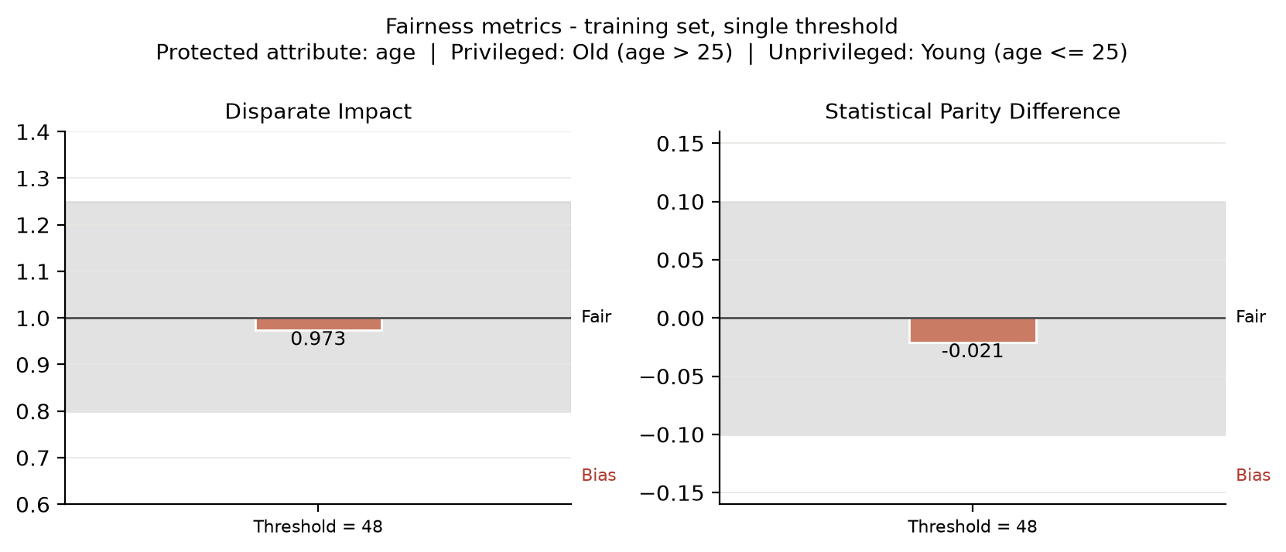
- Figure 3. Fairness metrics for the single-threshold model on the training set.
Fairness metric | Definition | Computed value | Ideal value | Bias interpretation
Disparate Impact | P(approved | unpriv) / P(approved | priv) | 0.8763 | 1.0 | No significant bias; within acceptable range [0.8, 1.25]
Statistical Parity Difference | P(approved | unpriv) - P(approved | priv) | -0.1012 | 0.0 | Bias slightly favors the privileged group; near the fairness threshold
- Table 4. Fairness metrics for the single-threshold model on the training set.

Step 6 — Mitigate Bias in the Training Set

Step 6.1 and 6.2 — Different Thresholds by Group
To reduce bias, I selected different thresholds for the privileged and unprivileged groups. The optimized values were a privileged threshold of 58 and an unprivileged threshold of 48. This optimization was performed using Disparate Impact as the fairness objective while retaining profitability as a constraint. The resulting thresholds decrease the approval-rate gap while preserving the same profit as the single-threshold solution.
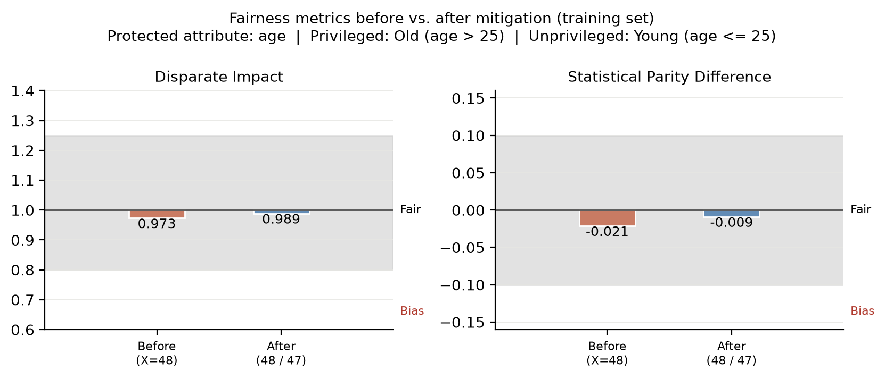
- Figure 4. Fairness metrics before and after mitigation.
Group | Threshold | Approval rate
Privileged: Old (age > 25) | 58 | 0.721
Unprivileged: Young (age <= 25) | 48 | 0.717
- Table 5. Optimized thresholds and resulting approval rates after mitigation.
The optimized thresholds yield a profit of 2,290, matching the original threshold result, while reducing the fairness gap dramatically. After mitigation, the privileged approval rate is 0.721 and the unprivileged approval rate is 0.717. The resulting fairness metrics are a Disparate Impact of 0.9956 and a Statistical Parity Difference of -0.0032, both of which are well within the fair range. This indicates the mitigation step was effective in improving fairness without sacrificing profit.

Step 7 — Post-Mitigation Analysis
The fairness metrics show that the original single-threshold model slightly favored the privileged group. Although the initial Disparate Impact remained within a broadly acceptable range, the Statistical Parity Difference suggested that younger applicants were being approved less often than older applicants. This small but meaningful difference highlights why it is important not to rely on a single metric when evaluating fairness. A model can seem acceptable under one measure while still producing inequitable outcomes in real-world decisions.
The mitigation step was effective. By raising the approval threshold for the privileged group while keeping the unprivileged threshold at 48, the approval-rate gap narrowed substantially while profit stayed constant. The fact that fairness improved without reducing profit is especially important because it suggests that equity and economic utility are not necessarily in conflict. At the same time, this outcome also makes me more cautious about fairness interventions in real settings, because threshold adjustments can be sensitive to the data and to the social context in which the model is being used.
There are still important limitations to this approach. A fairness intervention that works for one metric may become less effective under another, and the underlying score can still reflect historical inequities present in the dataset. In other words, fairness is context-dependent and cannot be solved by a single technical adjustment alone. For this reason, I would treat mitigation as one part of a broader process involving auditing, policy review, and continual evaluation rather than as a complete solution to bias in lending decisions.

References
Kamiran, F., & Calders, T. (2012). Data preprocessing techniques for classification without discrimination. Knowledge and Information Systems, 33(1), 1–33.
Castelnovo, A., Crupi, R., Regoli, A., Penco, C., & Cosentini, A. (2022). A clarification of the nuances in the fairness metric landscape. Scientific Reports, 12(1), 1–18.
Bellamy, R. K. E., Dey, K., Hind, M., et al. (2019). AI Fairness 360: An extensible toolkit for detecting, understanding, and mitigating unwanted algorithmic bias. IBM Research.
Google PAIR. (2018). The What-If Tool: Code-free probing of machine learning models.

Here are instructions for Microsoft Word, Apple Pages, and Google Docs.
In-line citations are preferred over footnotes, and we favor APA citation format for both in-line citations and reference lists. Refer to the Purdue Online Writing Lab, or follow the above examples. You should use the Footnote paragraph style, with 8.5 point text and 14 point line spacing.

